**Дата**: 14.04.2025

**Клас**: 5-АБ

**Предмет**: англійська мова

**Тема:** Чи ти коли-небудь…? Урок граматики. Минулі часи.

**Мета:** формувати навички вживання лексичних одиниць по темі; удосконалювати навички читання, аудіювання й усного монологічного мовлення; розвивати пізнавальні інтереси учнів; виховувати інтерес до самостійного пошуку потрібної інформації, а також загальну культуру учнів.

**Вчитель**: Руда Д.В.

Хід уроку

1.Greeting

Good afternoon, guys! I’m pickled pink to see you. Are you ready to start our lesson? All set?

2. Повторення

Повторити Irregular verbs .

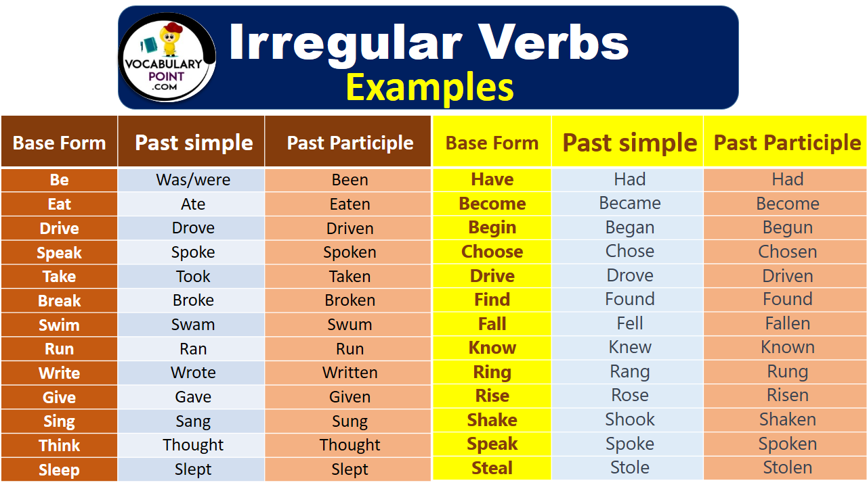

***Вивчити словник (бути готовим до слоникового диктанту) :***

*Careful-обережно (кеафул)*

*Slippery-слизько (сліпері)*

*To put on- одягати (пут он)*

*Overcast: covered with clouds; no sun is visible.- похмуро, сонця нема (овекаст)*

*"Under the weather": feeling ill or in low spirits. (e.g., "I'm feeling a bit under the weather today, so I'll stay home from work.")- мати погане самопочуття ( анде за везе)*

.

*Drizzle-мряка(дрізл)*

*Showers- a [short](https://dictionary.cambridge.org/dictionary/english/short" \o "short) [period](https://dictionary.cambridge.org/dictionary/english/period" \o "period) of [rain](https://dictionary.cambridge.org/dictionary/english/rain" \o "rain) or [snow](https://dictionary.cambridge.org/dictionary/english/snow" \o "snow)*

*Downpour- a lot of [rain](https://dictionary.cambridge.org/dictionary/english/rain" \o "rain) in a [short](https://dictionary.cambridge.org/dictionary/english/short" \o "short) [time](https://dictionary.cambridge.org/dictionary/english/time" \o "time) (дайн пор)*

*Flood-повінь(флад)*

*Hail-град(хейл)*

*Sleet-мокрий сніг(сліт)*

*Snowflake-сніжинка(сноуфлейк)*

*Blizzard-хуртелиця (блізард)*

*Mild: moderate in temperature; neither hot nor cold- помірний, м’який (майлд)*

*"Every cloud has a silver lining": every bad situation has some positive aspect to it. (e.g., "I lost my job, but I found a better one soon after. Every cloud has a silver lining.")- нема лиха без добра( ідіома)*

*To expect-очікувати(експект)*

*To report-повідомити(ріпот)*

*Chilly-прохолодний(чілі)*

*To get cold-холоднішати*

*It`s raining cats and dogs-сильно дощити (ідіома)*

*They cancelled the football game because it was raining cats and dogs.*

3. Wаrm up / Listening

Уважно слухати аудіо трек і дати відповідь на питання вчителя <https://www.youtube.com/watch?v=W6Y3GI1qP_o> .

4. Speaking

Have you ever appreciated a sunset?

Were you alone or with someone special?

Have you ever been a guest at a surprise party?

Has anyone ever thrown a surprise party for you?

Have you ever been in a fist fight?

Have you ever been on TV?

Have you ever been to a theatre? (Also spelling "theater.")

Have you ever broken a bone?

Have you ever broken up with someone?

Have you ever called your boyfriend or girlfriend by the wrong name?

Have you ever called your girlfriend/boyfriend "Honey?"

Have you ever changed your appearance a lot in a short time? (For example, hair style, hair color or weight)

Have you ever cheated on an exam?

Have you ever cried in public and embarrassed yourself?

Have you ever cried for no reason and felt good because of it?

Have you ever dated someone from another race, culture or religion?

Have you ever dated someone who didn't like you?

Have you ever dated a relative by accident?

Have you ever done something silly that you wish you had not done?

Have you ever driven a sports car?

Have you ever driven a truck?

Have you ever eaten in a restaurant and realized you have no money with you?

5. Writing

Виконати вправу 2 стр 114. Також 2, 3 стр 115.

Повторити граматику (past simple/present perfect).

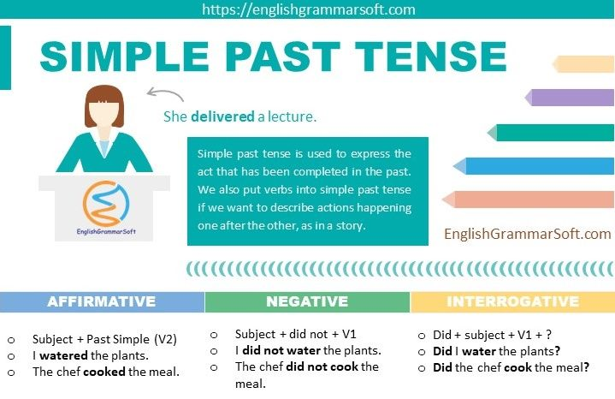

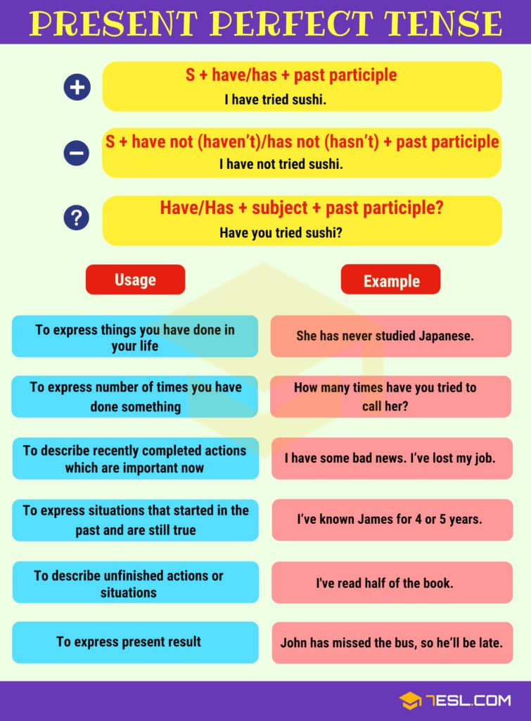

<https://www.liveworksheets.com/w/en/english-second-language-esl/46186>

**Directions :**

<https://wordwall.net/ru/resource/7083093/giving-directions>

<https://wordwall.net/ru/resource/18646601/giving-directions>

<https://wordwall.net/ru/resource/33186364/giving-directions>

<https://wordwall.net/ru/resource/6235458/giving-directions>

<https://wordwall.net/ru/resource/2520897/giving-directions>

<https://wordwall.net/ru/resource/16194748/giving-directions>

6. Homework

1. Виконати вправу 1 стр 118 у підручнику.

2. Вивчити слова на стр 115 у підручнику.